Exercise 9.1

**Interpretation**

The bar chart presents degree of preference for the various brands is consistent between areas 1 and 2, with Brand A receiving the least favour, followed by Brand B, and Other brands receiving the biggest share of favour in both areas.

Exercise 9.2

**Interpretation**

The bar graph compares the prevalence of heather species in two locations, A and B. findings:

Location A:

Absent: Approximately 14.3% of samples had no heather species.

Sparse: Around 39.3% showed sparse heather presence.

Abundant: The majority (about 46.4%) had abundant heather species.

Location B:

Absent: A higher percentage (about 45.5%) had no heather species.

Sparse: Approximately 31.8% showed sparse heather presence.

Abundant: Only around 22.7% had abundant heather species.

Location A has more abundant heather species overall, while Location B has a higher absence rate and lower abundance. These findings provide insights into ecological differences between the two areas

Exercise 9.3

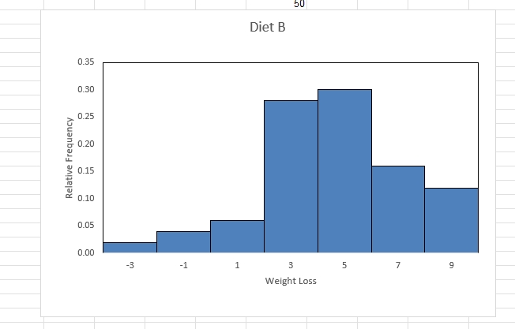

Interpretation:

Most individuals on Diet B experienced moderate weight loss (between 3 and 5 kg), while fewer individuals had no change or significant changes in their weights.

Exercise 9.6



Interpretation:

Most individuals on Diet B experienced moderate weight loss (between 3 and 5 kg), while fewer individuals had no change or significant changes in their weights.

Exercise 9.4

**Interpretation**

The charts presents degree of preference for the various brands is consistent between areas 1 and 2, with Brand A receiving the least favour, followed by Brand B, and Other brands receiving the biggest share of favour in both areas.